ELECTRONICS LAB PROJECT

TOPIC:

ZERO CROSSING DETECTOR

**TABLE OF CONTENTS**

|  |  |  |
| --- | --- | --- |
| **S.No** | **Topic** | **Pg.No** |
|  | Introduction | 3 |
|  | Aim | 3 |
|  | Theory | 4-5 |
|  | Equipment/Components | 5-6 |
|  | Circuit Diagram | 7 |
|  | Theoretical Graph | 7 |
|  | Simulation Diagram | 9 |
|  | Simulation Graph | 10-11 |
|  | Result | 12 |
|  | Application and Uses | 12-13 |
|  | References | 14 |

**INTRODUCTION**

A zero-crossing detector identifies the transition of a signal from positive to negative or negative to positive and provides a pulse that coincides with zero voltage of the signal. At high frequencies, this task becomes increasingly challenging especially if perfect accuracy is demanded.

A zero-crossing detector circuit using an op-amp can be used as a comparator. It is used to produce an output stage switch when the input crosses the reference. this output of the comparator can be used in many applications like a control gate, LED indicator etc.

Zero crossing circuits are used in energy observation systems which measure values such as voltage, current, frequency and power factor of the system. This is because capacitive and inductive loads as well as switching equipment distort the grid and produce harmonics. Hence, these measurements are not accurate due to the distorted signal waveforms and harmonics. Zero crossing detecting circuits help measure these accurately that are not affected by distortions from the grid and harmonics.

**AIM**

To simulate a zero-crossing detector circuit using Op-amp and Optocoupler and obtain the input and output waveforms to realize the working of a zero-crossing detector.

**THEORY**

Zero Crossing Detector are of two types-

1. Inverting

The non-inverting terminal is grounded and the input signal is connected to the inverting terminal.

*Case a*:

Aol = open loop gain

Vin < 0

Vd = V2 - V1

= Vref - Vin

= 0 - Vin

Vd = -Vin

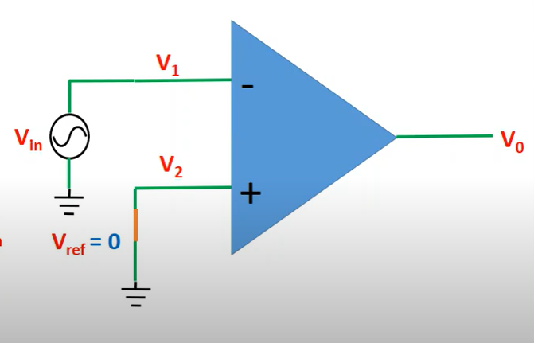 = +Vin (since Vin<0)

Vout = +Aol*Vd  > 0

Case b:

Aol = open loop gain

Vin > 0

Vd = V2 - V1

= Vref - Vin

= 0 - Vin

Vd = -Vin

= -Vin (since Vin>0)

Vout = -Aol*Vd <0

1. Non-Inverting

The inverting terminal is grounded and the input signal is connected to the non-inverting terminal.

Case a:

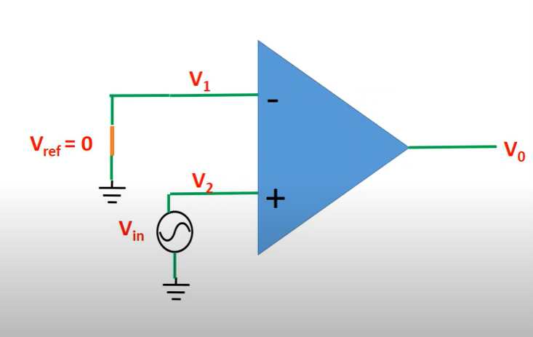Aol = open loop gain

Vin < 0

Vd = V2 - V1

= Vin - 0

= Vin

Vd = Vin

= -Vin (since Vin < 0)

Vout = -Aol*Vd < 0

Case b:

Aol = open loop gain

Vin > 0

Vd = V2 - V1

= Vin- 0

= Vin

Vd = Vin

= Vin (since Vin > 0)

Vout = +Aol*Vd >0

Diodes can also be used in the circuit as clamp diodes. These diodes are used to guard the operational amplifier against damage due to an increase in Vin.

In some particular applications, the Vin may be a low-frequency waveform that causes an interruption in time for the Vin to cross the zero level. Furthermore, this causes a delay in the Vout to switch between the two saturation levels. At the same time, the input noises in the IC may cause the Vout to switch between the saturation levels. Thus, zero crossings are identified for noisy voltages in addition to the Vin. These problems can be detached by using a re-forming feedback circuit with positive feedback that causes the Vout to switch faster. So, removing the possibility of any false zero crossing due to noise in voltage at the input of the op-amp.

**Equipments/Components:**

Sl. No Name and Specification Quantity required:

1 Dual power supply +/- 6V - 2

2 Function generator (0- 1MHz) - 1

3 Oscilloscope - 1

4 Resistors 10k - 4, 2.2k - 1

5 IC 741C - 1

6 Diodes (1N914) - 2

7 Optocoupler 4N25

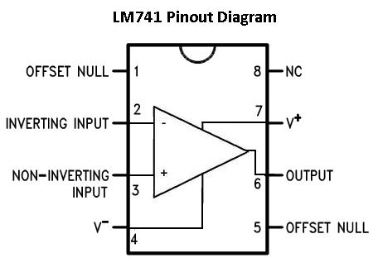

**IC 4N25 PINOUT DIAGRAM**

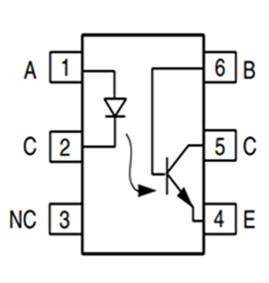

An optocoupler is a very common and valuable electronic component that uses light for its operation. The basic design of an optocoupler consists of an LED that acts as a source producing infra-red light and a photo-transistor that detects the emitted infra-red beam. These circuits are electrically isolated from each other and they use light for their operation. It is analogous to that of a transformer. Basically current from the source signal passes through the LED and it emits an infra-red light. This emitted light falls upon the base side of the transistor and hence the BJT gets switched ON and becomes active. As it uses light for its operation and its circuits are isolated it is also called an opto-isolator. An advantage of optocouplers is that it pervents high voltages from affecting the system that recieves the signal. Commercially available optocouplers withstand voltages of upto 10 Kv.

**CIRCUIT DIAGRAM AND THEORITICAL GRAPHS**

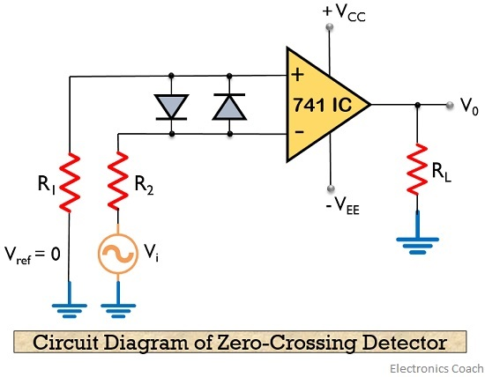

CIRCUIT DIAGRAM FOR ZERO CROSSING DETECTOR USING OP-AMP

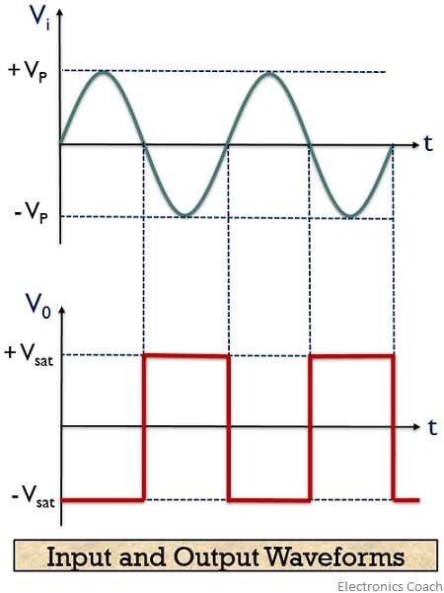

THEORITICAL GRAPH FOR ZERO CROSSING DETECTOR USING OP-AMP

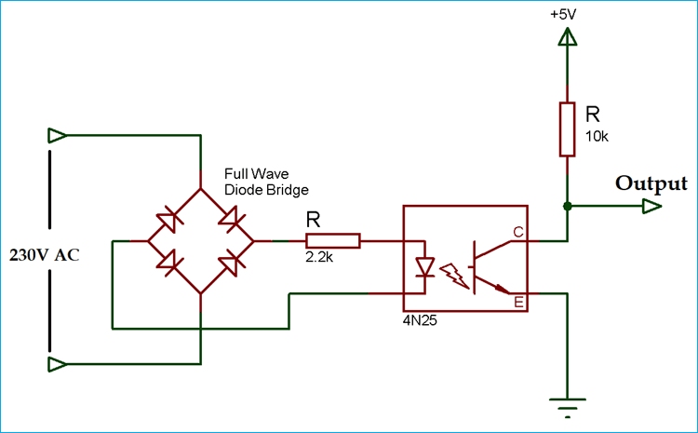

CIRCUIT DIAGRAM FOR ZERO CROSSING DETECTOR USING OPTOCOUPLER

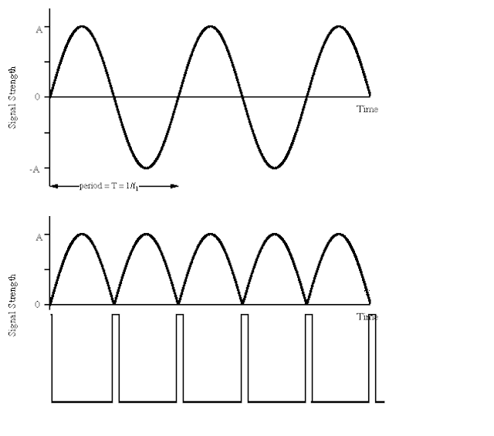

THEORETICAL GRAPH FOR ZERO CROSSING DETECTOR USING OPTOCOUPLER

**SIMULATION DIAGRAM AND GRAPHS**

**The project has been simulated in LTSpice XVII**

**Inverting ZCD**

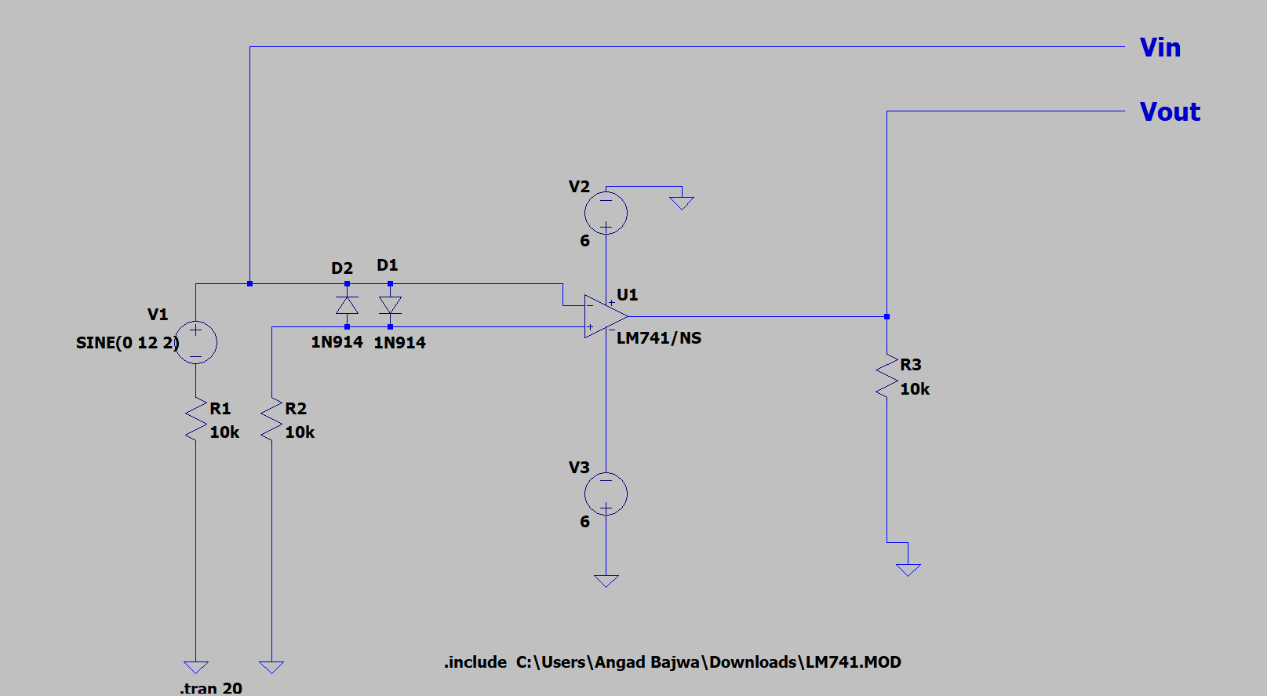

**Circuit diagram**

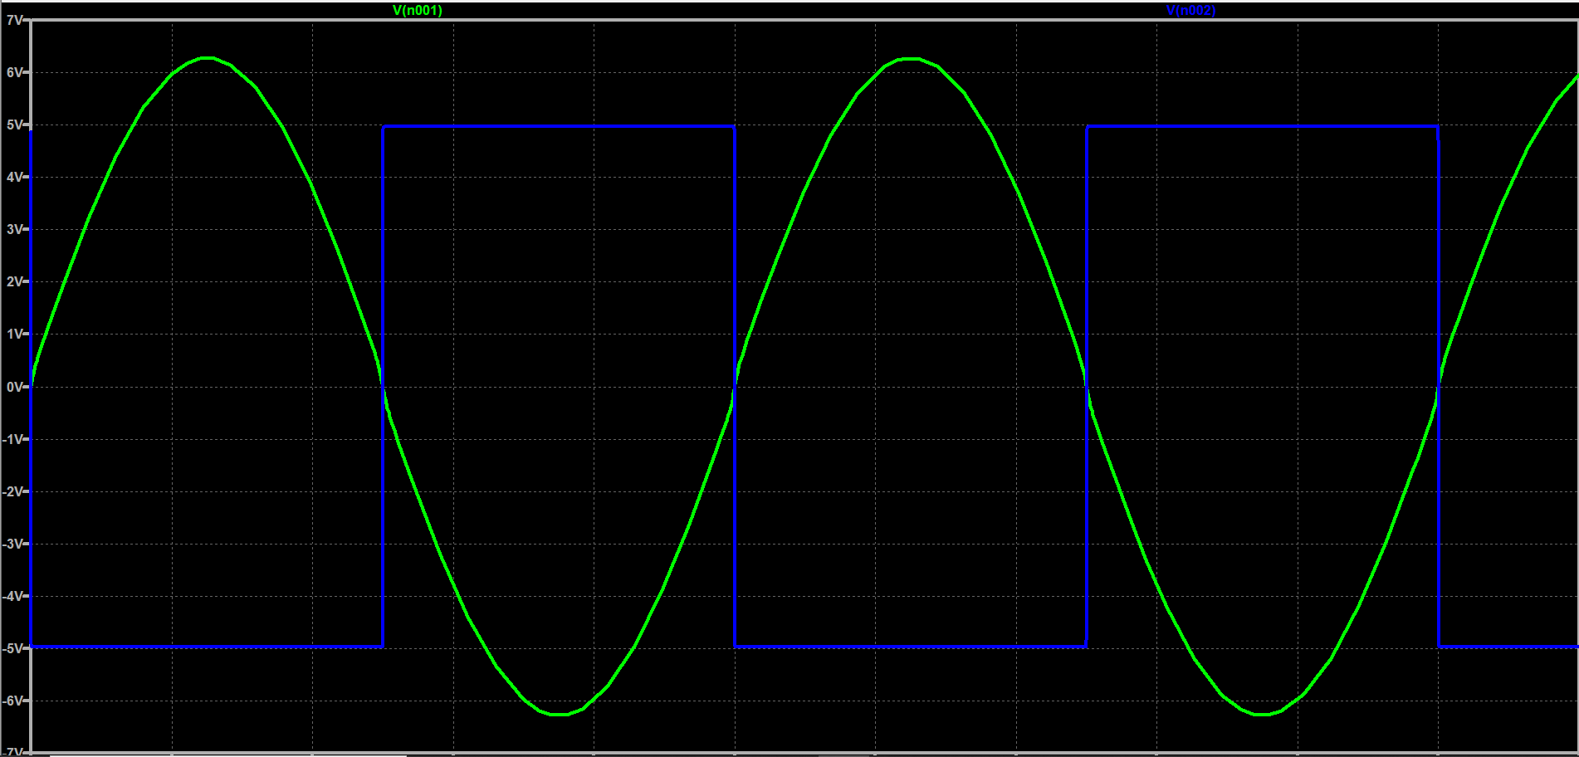

**Waveform**

**Non-Inverting ZCD**

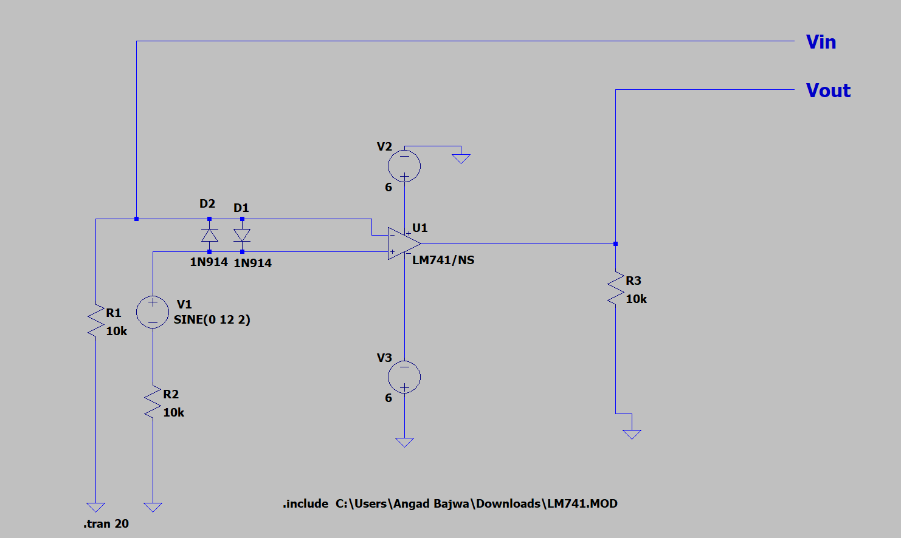

**Circuit diagram**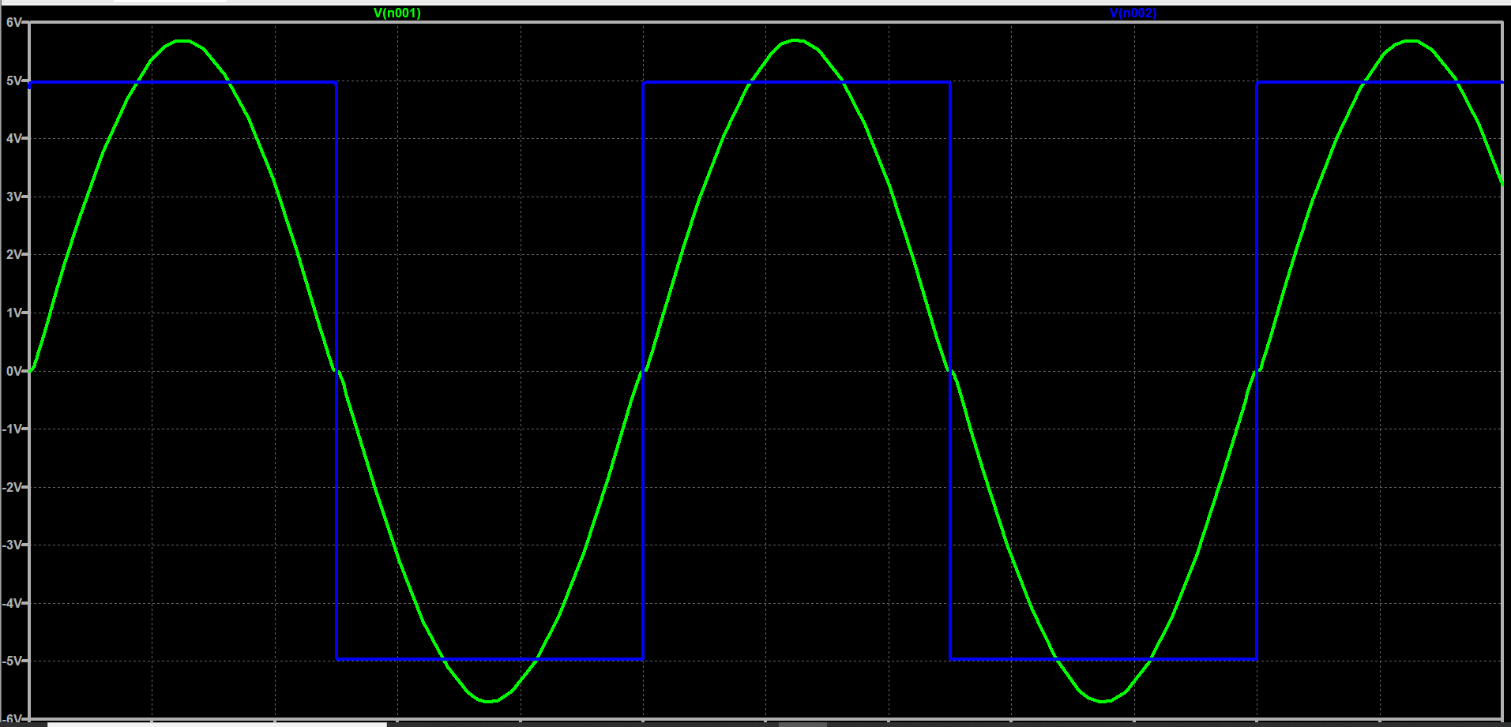

**Waveform**

**Optocoupler circuit**

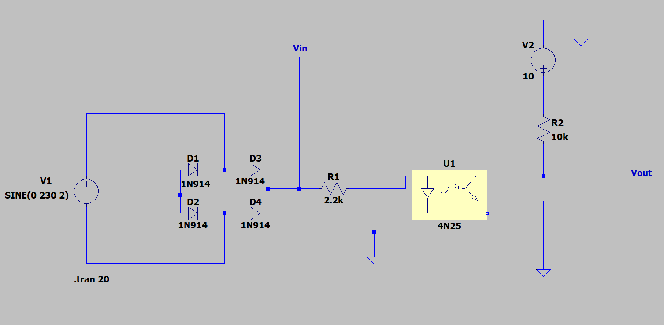

**Circuit diagram**

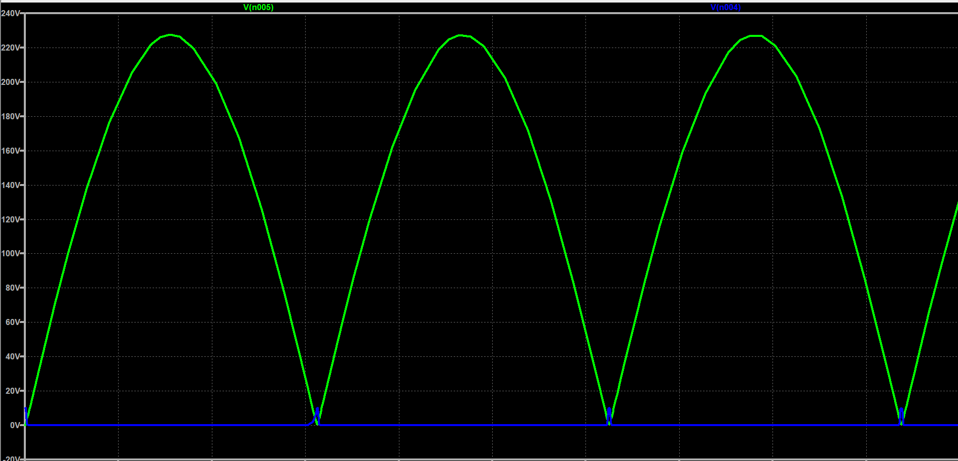

**Output**

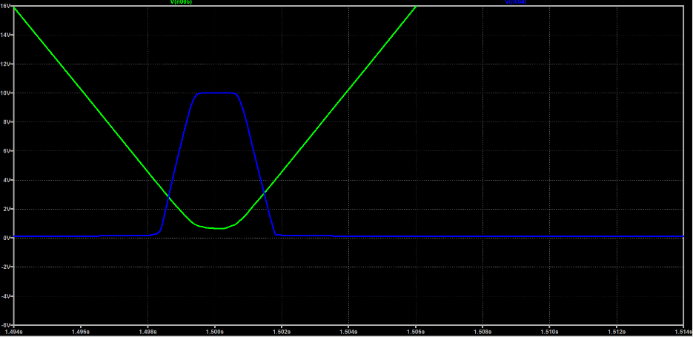

**RESULT**

A zero-crossing detector circuit was designed and simulated using an operational amplifier and optocoupler. The input and output waveforms were plotted and analysed.

**APPLICATION AND USES**

Zero crossing detector has many applications in a wide number of fields.

***Zero Crossing Detector as Phasemeter***

A zero Crossing Detector can be used to measure the phase angle between two voltages. A sequence of pulses in the positive and negative cycles are acquired to measure the voltage between the time interval of the pulse of sine wave voltage and second sine wave. This interval of time is related to the phase difference between the two input sine wave voltages. The use of phase meter ranges from 0° to 360°

***Zero Crossing Detector as Time Marker Generator***

For an input sine wave, the output of the zero-crossing detector being a square wave will pass through an RC series circuit. If the RC time constant is very small compared to the period (T) of the input sine wave, then the voltage across R of the [RC circuit](https://www.elprocus.com/rc-snubber-circuits/) called VR will be a series of positive and negative pulses. If the voltage VR is applied to a [clipper circuit](https://www.elprocus.com/types-of-clipper-and-clamper-circuits-and-applications/) using a diode D, the load voltage VL will have only positive pulses and will clip away the negative pulses. Therefore, a zero-crossing detector whose input is a sine wave has been changed into a sequence of positive pulses at T interval by adding a network RC and a clipping circuit.

***Zero Crossing Detector for RF Noise Elimination*** An [electronic light dimmer circuit](https://homemade-circuits.com/2012/04/how-to-make-simplest-triac-flasher.html) emits a lot of RF noise into the atmosphere and also into mains grid causing unnecessary dumping of harmonics.This happens due to the rapid intersection of the triac conduction across the positive/negative cycles via the zero crossing line, and in the zero crossing transition the triac is subjected to an undefined voltage zone producing rapid current transients which emits RF noise.

[A zero crossing detector is added to triac based circuits](https://homemade-circuits.com/2011/12/efficient-electronic-relay-ssr-circuit.html) eliminating RF noise by allowing the triac to fire only when the AC cycle has crossed the zero line perfectly, ensuring a clean switching and eliminating the RF transients.

***Zero Crossing Detector for AC Motor Monitoring***

Monitoring a single-phase AC motor’s rotation can be done by two zero crossing detectors. Its can also detect many types of failures, like open or short circuits in any winding, open or short circuits in the motor capacitor or its wires, relay, triac and fuse failures. Even a stalled rotor can be detected. Any of these failures will cause the motor not to rotate.

Zero crossing detection is used in many other many applications:

* Controlled voltage rectifiers
* Resonant power supplies
* Induction motor speed control and soft starters
* AC power controllers
* Frequency counter
* Switching purposes in power electronics

Lastly, a key feature of the detector presented is its inexpensive structure. The detector has a small number of components and none of them are complicated. These components can easily be provided on the market cheaply. The zero-crossing circuit presented can be used for systems requiring sensitive and errorless measurements.

**References**

* Circuits Today- Zero Crossing Detector
* Circuit Digest- Zero Crossing Detector
* Learning Electronics Youtube Channel
* Electronics Tutorial- Optocoupler
* Components101- Optocoupler,
* El-Pro-Cus Zero Crossing Detector
* Microcontrollerslab- Zero Circuit Examples and Applications
* EmergingTechs – Zero crossing detector using optocoupler
* EDN – z=Zero-crossing-detector-uses-only-a-few-high-voltage-parts